Scope Document
Faultline-DevOps Incident Management Agent
An AI-Driven Automated Incident Detection and Remediation System

Submitted By
Zaki Haider – 231572
Muhammad Rafay Tariq – 231546
Muhammad Bilal Adnan – 231581

Supervisor
Dr. Ashfaq Hussain Farooqi
Co-Supervisor
M. Junaid Nazar

Department of Computer Science
Air University Islamabad (AU)

Supervisor Meeting Log
Meeting | Discussion | Task Assignment | Supervisor Signature
Meeting 01  Date: 23/1/2026 | New FYP idea proposed | Start working on scope document.
Meeting 02  Date: 3/3/2026 | Initial Scope Document Review | Build complete flow and work on mockups
Meeting 03  Date:3/6/2026 | Finalized the Scope/ Mockups | Presentation Design

Table of Contents
1. Introduction 1
2. Related System Analysis 1
3. Problem Statement 2
4. Problem Solution / Objectives of the Proposed System 3
4.1 Objectives 3
5. Scope 3
5.1 In-Scope 4
5.2 Out-of-Scope 5
6. System Architecture Overview 5
7. Modules 7
7.0 User Management and Authentication 7
7.1 Static Code Analyzer 7
7.2 Production Logs Aggregator and Classifier 7
7.3 Incident Playbook Generator. 8
7.4 Remediation Runner 8
7.5 Incident Ledger 8
7.6 Reporting and Analytics 9
7.7 Voice Call Agent 9
7.8 Subscription & Tier Management 10
8. Functional Requirements 10
9. Non-Functional Requirements 11
10. System Limitations / Constraints 11
11. Data Gathering Approach 12
12. Tools and Technologies 13
13. Project Stakeholders and Roles 14
14. Module-based Work Division 14
15. Assumptions 14
16. Risks and Mitigation 15
17. Expected Deliverables 15
18. Gantt Chart 16
19. UI Mock-ups: 17
20. References 20

1. Introduction
The development of cloud-native systems and microservices has created new challenges for current software development because both technologies result in greater system complexity than before. The DevOps teams at present must manage three different problems which include infrastructure outages and log errors and service disruptions. The incident management process which depends on human monitoring and emergency response requires more development because it fails to deliver effective results which leads to extended MTTR times and major financial or operational hazards.
The AI-Driven DevOps Incident Management System serves as a project which creates an intelligent system that connects complex system telemetry with practical system solutions. The system establishes new methods for detecting production incidents through its combination of automated monitoring and LLM-powered root cause analysis (RCA) and established remediation methods.
The platform stands out because it gives special emphasis to making its features accessible and interacting with users through preventive communication. The system enables DevOps teams to decrease manual work and decrease operational disturbances through its Agent-based system, which combines production monitoring with code quality assessment into a centralized process.

2. Related System Analysis
Current incident management and DevOps monitoring operations use multiple platforms and tools which target specific operational aspects. However, the complete AI solution which analyzes code and fixes production problems does not exist in any of the current systems. The following table summarizes the existing system limitations while demonstrating how our new platform delivers a more complete solution.
Application / Tool | Weakness | Proposed Project Solution
PagerDuty | Primarily an incident response and on-call management tool; requires manual investigation and lacks automated remediation or static code analysis capabilities. | Can Provide end-to-end automation from static code analysis to AI-inferred remediation without manual intervention.
Splunk ITSI | Highly effective for log monitoring but expensive, requires significant configuration, and does not perform automated code analysis or remediation. | Offers integrated log aggregation, anomaly detection, and automated remediation in a unified, lightweight academic-grade system.
SonarQube | Performs excellent static code analysis but is entirely limited to the pre-deployment phase; does not address production incidents or provide remediation. | Complements pre-deployment code analysis with real-time production monitoring, creating a continuous quality and reliability pipeline.
GitHub Actions / CI-CD Tools | Automate build and test pipelines but do not perform runtime anomaly detection, incident management, or post-deployment remediation. | Extends CI/CD capabilities with AI-based incident detection and intelligent remediation, bridging the pre- and post-deployment gap.
Data Dog/ New Relic | Ingests server telemetry and logs to create stack traces and observe cloud environments. They operate strictly as diagnostic observability tools and do not execute automated fixes. | Extends Detection in to remediation through Agentic Mitigation.

3. Problem Statement
Organizations need to establish a single intelligent system for their operational needs because modern cloud-native software development teams must sustain system uptime while they handle incidents and deploy software updates. The process of creating static analysis systems and manual log monitoring tools results in undetected code vulnerabilities and system outages and performance degradation. The current incident detection systems function as reactive systems which notify engineers about problems only after they have already taken place. This system behavior leads to longer recovery times which results in a worse experience for users. Having their incident documentation unorganized, the staff members are particularly slow in resolving problems because they depend on manual methods to solve them.

4. Problem Solution / Objectives of the Proposed System
To address the identified operational challenges, we propose the development of an AI-Driven DevOps Incident Management Agent. This system will automate the complete incident management lifecycle by integrating intelligent static code analysis, real-time production monitoring, anomaly detection, and automated remediation. The platform will serve as a centralized intelligence layer over existing DevOps infrastructure, enhancing reliability and reducing the mean time to resolution.

4.1 Objectives
- To develop an AI-powered agent capable of performing static code analysis on GitHub repositories, identifying vulnerabilities, inefficiencies, and policy violations with detailed developer-facing reports.
- To implement a production log aggregation and classification system using machine learning models to identify anomalous patterns, container degradation signals, and abnormal system behavior.
- To build an automated incident detection pipeline that correlates code quality signals and production anomalies to infer probable root causes with high accuracy.
- To build a remediation runner that run remediation playbooks and ensures reliability and availability.
- To maintain a comprehensive incident timeline and audit log that ensures full traceability of all detected incidents, AI inferences, and applied remediations.
- To generate structured, stakeholder-ready reports summarizing incident history, system health, and code quality metrics for both technical and non-technical audiences.
- To deploy an automated voice-call agent that proactively contacts the engineering team to communicate system errors with detailed incident summaries, and notifies end users about service disruptions along with the expected restoration time.

5. Scope
The project will create and test an AI-based DevOps Incident Management system which will operate as an academic Final Year Project (FYP). The system bridges the gap between pre-deployment code quality and post-deployment production stability by integrating intelligent subsystems for automated detection, reasoning, and remediation.

5.1 In-Scope
- The User Management and Agentic Role-Based Access Control (ARBAC) system enables secure authentication through Multi-Factor Authentication (MFA) and Agentic Role-Based Access Control (ARBAC) which establishes different levels of AI bot autonomy ranging from Read-Only to Autonomous capability.
- The Static Code Analysis system implements a GitHub App which applies statistical machine learning and transfer learning methods to identify and resolve code quality problems while producing flow diagrams and automating the creation of pull requests for code remediation.
- The Production Log Intelligence system captures and processes containerized environment logs from Docker Kubernetes through its machine learning models which detect system failures and memory overuse problems.
- AI-Powered Root Cause Analysis (RCA) uses Langchain agents and Retrieval-Augmented Generation (RAG) technology to process logs and access historical runbooks for creating incident playbooks which include confidence scores.
- The Automated Remediation Runner functions as a safety-first execution system which conducts pre-execution environment assessments to control automated script operations while implementing a Human-in-the-loop approval system for all critical procedures.
- The Immutable Incident Ledger system uses PostgreSQL to create a permanent audit trail which captures system events and AI inference results and user manual system overrides while displaying system events on a timeline for post-mortem investigation.
- Reporting and Analytical system provides automated reporting through PDF and JSON document exports while enabling Slack ticket management in real time and using a Voice Agent to make outbound calls which deliver incident information and recovery time estimates to stakeholders.
- The Subscription and Tier Management module enables service level control through tier-based feature access which includes Agentic bot limits and LLM token quotas and automated scan frequency control together with a payment gateway for various billing scenarios.

5.2 Out-of-Scope
- The academic project will exclude all activities in these specified areas which have been defined through document development.
- The system functions through its complete enterprise operations during both academic demonstration and controlled testing environments. The system cannot function in environments that demand 99.99% uptime and require extensive horizontal scaling capabilities.
- The system functions through its modular design system which enables operations with all major cloud providers. The scope is limited to Azure/AWS and the GitHub API; support for GCP, or IBM Cloud is excluded.
- The system provides software-based incident management capabilities which control all physical infrastructure operations. The system does not have the ability to track or manage physical hardware components or cooling systems or power distribution systems or security monitoring systems used in data centers.
- The user interface will be delivered exclusively as a web-based dashboard. The project will not develop native applications for iOS which uses Swift or for Android which uses Kotlin.
- The system will use a subscription model to control system access but it will not manage actual financial operations which include international tax calculations for VAT and GST and regional billing standards and automatic currency exchange between dif.

6. System Architecture Overview
The system follows a modular, event-driven microservices architecture. The system consists of two workflows:
The First one, is initiated upon a code commit to a connected GitHub repository, triggering the Static Code Analyzer GitHub bot for static analysis. If any error or suggestion is found the bot informs the system, and generates a PR.
The Second Workflow works with the production environment. The Log Aggregator continuously collects and classifies production environment logs. The Playbook Generator works with these aggregated logs to infer Production Errors and Issues such as: container degradation, Api service degradation etc. and generate a remediation playbook. The remediation runner runs these playbooks after ensuring environment compatibility.
All events, inferences, and actions are recorded in the Incident Timeline and Auditing Module. The Reporting Module aggregates data to generate structured reports, while the Voice Agent provides a supplementary natural language interface.
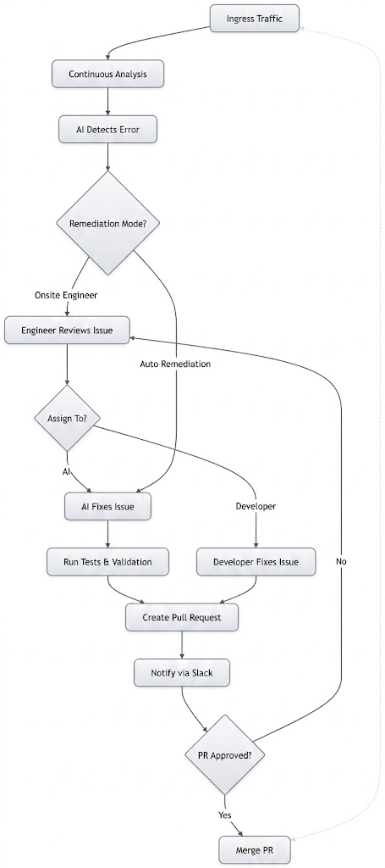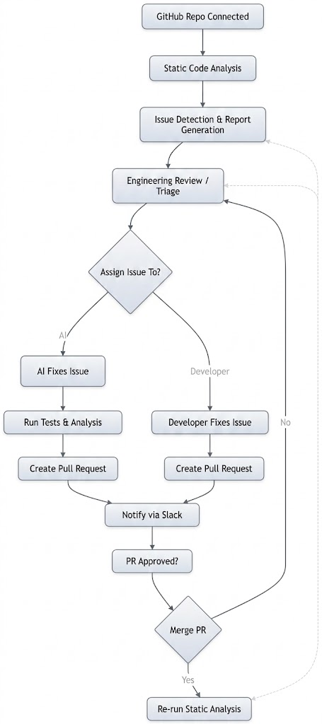

7. Modules

7.0 User Management and Authentication
User Management is responsible for managing DevOps engineers, and Agentic users within the incident management system. It ensures secure authentication, Non-Repudiation Service, and ARBAC.
- Authenticates users via identity providers with support for multi-factor authentication.
- Logs all user activities including logins, approvals, overrides, and manual remediation actions for audit and compliance purposes.
- Agentic Role Based Access Control, defines the autonomy for each Agentic bot (e.g., Read-Only, Suggestive, or Autonomous).
- Non-Repudiation logging. Action performed by Agentic Role or by a human is logged and timestamped.

7.1 Static Code Analyzer
Static Code Analyzer is a GitHub App; it works closely with GitHub repository and can perform the following tasks:
- Detect and fix code quality issues and programming errors using statistical machine learning and transfer learning–based models.
- Generate Data-flow and Control-flow Diagrams.
- Validate fixes through compilation checks or testing mechanisms.
- Generate Incident on Error detection with severity flag (Critical, Normal, Minor).
- Create PR on Auto-Remediation.

7.2 Production Logs Aggregator and Classifier
The Log Aggregator and Classifier module is responsible for collecting, normalizing, and classifying production environment logs in near real-time.
- Aggregates logs from multiple sources including application logs, container runtime logs, and infrastructure metrics.
- Normalizes heterogeneous log formats into a unified structured schema for downstream processing.
- Applies machine learning classification models to identify normal versus anomalous log patterns.
- Flags critical anomalies including container crash loops, memory exhaustion patterns, abnormal API response time distributions, and bandwidth signals.

7.3 Incident Playbook Generator.
Incident Playbook Generator serves as a Root Cause Analysis Engine. It ingests server logs from the Log Aggregator and performs the following tasks:
- Employs Langchain agents to dynamically select appropriate reasoning chains based on incident type and context.
- Integrates multiple LLM to leverage their respective strengths for different reasoning tasks.
- Utilizes Retrieval-Augmented Generation (RAG) by providing relevant historical incident data, runbooks, and documentation as context for more accurate and grounded inference.
- Generates an Incident Playbook with supporting rationale, confidence scores, and alternative action suggestions.

7.4 Remediation Runner
The Remediation Runner is responsible for running remediation playbooks it can perform the following tasks:
- Perform a Pre-execution Safety check to verify target environment state
- Automated Script Execution
- Maintain Human in the Loop. The runner shall support Approval interruption for high severity actions
- The runner must maintain a library of playbooks in correspondence with Error

7.5 Incident Ledger
Incident ledger maintains a complete, immutable record of all system events, ensuring full traceability from incident detection through to resolution.
- Records every incident detection event, AI inference, and remediation action with precise timestamps.
- Stores structured audit entries in a persistent database (PostgreSQL) for efficient querying and reporting.
- Supports filtering and search by incident type, severity, affected service, time range, and resolution status.
- Provides a timeline visualization interface on the web dashboard for interactive post-incident analysis.

7.6 Reporting and Analytics
The Reporting and Analytics aggregates data from the incident timeline, code analysis results, and system health metrics to produce structured, professional-grade reports for diverse audiences.
- Generates technical reports detailing code quality findings, anomaly statistics, and remediation action summaries.
- Produces summary reports with system health indicators, incident frequency trends, and key performance metrics such as MTTR.
- Supports export to PDF and structured data formats (JSON, CSV) for integration with external reporting tools.
- Generate and Maintain Slack Tickets on Appropriate Slack Channels.

7.7 Voice Call Agent
The Voice Agent system functions as an automatic communication service which alerts engineers and stakeholders about system problems through telephone calls instead of requiring them to monitor the dashboard constantly.
- The system initiates automatic voice calls to the engineering team when it detects a critical incident or system error.
- The report provides a condensed overview of the problem which shows the error type and affected services along with their severity level.
- The system informs end users about service interruptions while providing them with current information on system status and expected time for service restoration.
- The system creates call messages in real time by using the current incident information.
- The system enables escalation processes through two methods: it either retries calls or it informs higher-level staff members when the incident still needs resolution.

7.8 Subscription & Tier Management
The Subscription and Tier Management system controls user access to system functions by establishing service tiers which separate access rights while it handles platform subscription billing operations.
- The system establishes various subscription tiers which include Basic Pro and Enterprise plans that provide distinct feature access limits.
- The system controls user access to platform features by establishing restrictions on Agentic bot usage LLM token consumption and automated scan execution.
- The system monitors user activity to confirm that users stay within their designated usage boundaries.
- The system establishes a connection to a payment gateway which enables both simulated and actual subscription billing operations.
- The system enables administrators to control subscription plans while they establish new pricing rates and track ongoing subscription activities.

8. Functional Requirements
FR-ID | Module | Requirement Description | Priority
FR-01 | Static Code Analyzer | The system shall connect to GitHub repositories via Github Apps and retrieve source code for analysis. | High
FR-02 | Static Code Analyzer | The system shall perform AI-driven static analysis and generate severity-categorized issue reports. | High
FR-05 | Log Aggregator | The system shall collect and normalize logs from Docker/Kubernetes containers and cloud services. | High
FR-06 | Log Aggregator | The system shall apply ML-based anomaly detection to classify log patterns as normal or anomalous. | High
FR-07 | Playbook Generator | The system shall use Langchain agents to infer root causes and generate remediation recommendations from incident context. | High
FR-08 | Playbook Generator | The system shall utilize RAG with historical incident data and runbooks to improve inference accuracy. | Medium
FR-11 | Incident Ledger | The system shall maintain a timestamped, immutable incident timeline for all system events. | High
FR-12 | Reporting | The system shall generate technical and executive reports in PDF and structured data formats. | Medium
FR-13 | Voice Agent | The system shall accept and process natural language voice queries about system status and incidents. | Low

9. Non-Functional Requirements
NFR-ID | Category | Requirement Description
NFR-01 | Performance | The system shall complete static code analysis and generate a report within 60 seconds for repositories of up to 50,000 lines of code.
NFR-02 | Performance | Log anomaly detection shall operate with a latency of no more than 30 seconds from log ingestion to anomaly alert.
NFR-03 | Reliability | The Remediation Runner shall implement retry mechanisms with exponential backoff to handle transient module communication failures.
NFR-04 | Security | All API keys, cloud credentials, and sensitive configuration data shall be stored using environment variables or a secrets management service; never hard-coded.
NFR-05 | Scalability | The modular architecture shall support the addition of new cloud provider integrations without requiring redesign of existing modules.
NFR-06 | Maintainability | All modules shall be independently deployable and testable, following the single-responsibility principle.
NFR-07 | Usability | The web dashboard shall be responsive and accessible, providing incident data visualization with filter and search capabilities.
NFR-08 | Auditability | All audit log entries shall be immutable and retained for the complete duration of the project lifecycle.

10. System Limitations / Constraints
- The system will be developed and validated in an academic setting through simulated environments which use local Kubernetes via Minikube or trial Azure subscriptions to test their performance.
- The Static Code Analyzer and Remediation Runner function exclusively within the GitHub API and Kubernetes ecosystem respectively; this version does not enable integration with other VCS or cloud providers.
- The Log Aggregator system requires real-time operation but network latency together with ML classification processing costs create a time gap that delays detection of incidents.
- The Agentic Role-Based Access Control system needs human-defined policy configurations to function properly because improper setting of autonomy levels will result in either excessive control over bot activities or unauthorized changes to system operations.

11. Data Gathering Approach
Data gathering for this project encompasses multiple complementary strategies to ensure the system is built on representative, high-quality input data.
- Production Log Datasets: Publicly available log datasets such as the LogHub benchmark suite (containing logs from Hadoop, Apache, Linux, etc.) will be used to train and evaluate the anomaly detection models.
Dataset link: https://github.com/logpai/loghub/tree/master/Apache,
https://www.kaggle.com/datasets/mirzayasirabdullah07/cicd-pipeline-failure-logs-dataset-for-aiops
- GitHub Repository Code Samples: Open-source repositories containing known code vulnerabilities (e.g., OWASP Benchmark, CWE test cases) will be used to validate the Code Checker module's detection accuracy.
Dataset link: https://www.kaggle.com/datasets/simiotic/github-code-snippets/code/discussion
- Supervisor and Domain Expert Consultation: Regular meetings with the project supervisor will guide data selection, validation strategies, and model evaluation criteria.
- Cloud API Documentation: Azure Monitor and GitHub API documentation will inform the design of integration interfaces and the permissible scope of automated remediation actions.

12. Tools and Technologies
Table 2. Tools and Technologies for the Proposed Project
Category | Tool / Technology | Rationale
IDE | VS Code / IntelliJ IDEA | Primary development environment with robust debugging and extension ecosystem.
Frontend | React.js | Component-based UI framework for building the interactive web dashboard.
Backend | Python (FastAPI / Flask) | Lightweight, high-performance backend framework suited for AI/ML integration.
AI / NLP Framework | Langchain | Provides agent orchestration and chain abstraction for multi-model AI reasoning.
LLM APIs | PagerDuty, Transformer Model | State-of-the-art large language models for code analysis and incident reasoning.
ML Libraries | Scikit-learn, PyTorch / TensorFlow | Model training and evaluation for anomaly detection (Isolation Forest, LSTM).
Log Processing | Apache Kafka / Redis Queue | Message queue for real-time, asynchronous log ingestion and event streaming.
Database | PostgreSQL | Relational database for structured storage of audit logs and incident records.
Containerization | Docker / Kubernetes (Minikube) | Containerized deployment and local cluster simulation for testing.
Version Control | GitHub / Git | Source code management and integration point for code analysis workflows.
Reporting | ReportLab / pdfplumber | PDF generation library for automated report creation.
Testing | Pytest / Unittest | Unit and integration testing framework for Python modules.

13. Project Stakeholders and Roles
Table 3. Project Stakeholders for the Proposed Project
Role | Stakeholder
Project Sponsor | Air University Islamabad
Developer / Team Member | Zaki Haider – Full Stack & DevOps Engineer
Developer / Team Member | Muhammad Rafay Tariq – Backend & ML Engineer
Developer / Team Member | Muhammad Bilal Adnan – Full Stack Engineer
Supervisor | Dr. Ashfaq Hussain – Technical guidance and project oversight
Co-Supervisor (if any) | Junaid Nazar – Domain expertise support
Evaluating Body | Final Year Project Committee – Project evaluation and assessment

14. Module-based Work Division
Table 4. Module-based Work Division for the Proposed Project
Student Name | Registration No. | Role | Modules / Responsibilities
Zaki Haider | 231572 | Full Stack & DevOps Engineer | Static Code Analyzer, Playbook Generator,
Muhammad Rafay Tariq | 231546 | Backend & ML Engineer | Incident ledger, Voice Agent, Subscriptions and Tier Management
Muhammad Bilal Adnan | 231581 | Full-Stack Engineer | Web Dashboard, Reporting, Log Aggregator & Classifier, Remediation Runner

15. Assumptions
- GitHub repositories used for testing will either be publicly available open-source projects or repositories created specifically for academic demonstration purposes.
- LLM API access will be maintained throughout the project duration using academic or trial API keys with sufficient token quotas.
- A local Kubernetes cluster (Minikube) will be used as a substitute for a full cloud-deployed Kubernetes environment for log collection
- The anomaly detection models will be trained on publicly available log datasets and will not require access to sensitive organizational log data.
- Voice Agent functionality will be demonstrated in a controlled, low-noise environment to achieve acceptable speech recognition accuracy.

16. Risks and Mitigation
Risk ID | Risk Description | Likelihood | Impact | Mitigation Strategy
R-01 | LLM API rate limits or cost overruns may restrict development and testing throughput. | Medium | High | Implement response caching, use smaller models for non-critical tasks, and monitor API usage against budget limits.
R-02 | Anomaly detection ML models may exhibit high false positive rates on unseen log distributions. | Medium | Medium | Evaluate models on multiple log datasets, tune classification thresholds, and implement human-in-the-loop review for borderline cases.
R-04 | Scope creep due to the broad technical nature of the project may lead to incomplete module delivery. | High | High | Strictly prioritize core modules Static Code Analyzer, Log Aggregator, Langchain, as MVP; treat Voice Agent and as optional extensions.
R-05 | Inter-module integration complexity may introduce significant debugging overhead. | Medium | Medium | Define clear API contracts between modules early, use mocking for isolated unit testing, and conduct weekly integration testing.

17. Expected Deliverables
- The system operates as an entire AI-powered DevOps Incident Management tool which manages all stages of an incident from when it gets detected until its final resolution.
- The Voice Agent module operates successfully by making automated phone calls to engineers during major incidents while it shows them structured notifications about the ongoing incident.
- The subscription and tier management system enables users to access multiple service levels through feature-based access control which includes restrictions on agent usage and LLM token consumption and scan frequency limitations.
- The system observes resource usage through a usage monitoring system which assesses all aspects of resource consumption including AI agent activity and API interaction and automated scanning processes.
- The payment gateway module establishes a connection for both actual and simulated subscription billing processes.
- The database contains all essential components for incident management which includes monitoring systems and sample data for tracking incidents and sending notifications and executing resolution procedures.
- The dashboard provides a unified interface which shows current incidents together with system performance data and detailed operational information.
- The technical documentation package contains complete system details which include system architecture diagrams as well as API documentation and user manual.
- The testing suite contains all required tests which include unit tests and integration tests that confirm the functionality of essential system components.
- The report for the Final Year Project shows all required elements which Air University needs for submission.

18. Gantt Chart
Figure 1. Project Gantt Chart for DevOps Incident Management Agent
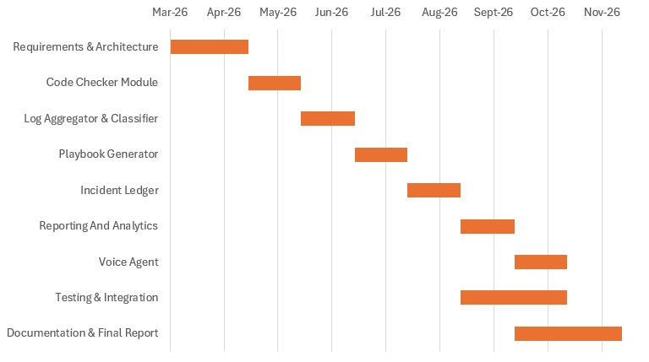

19. UI Mock-ups:
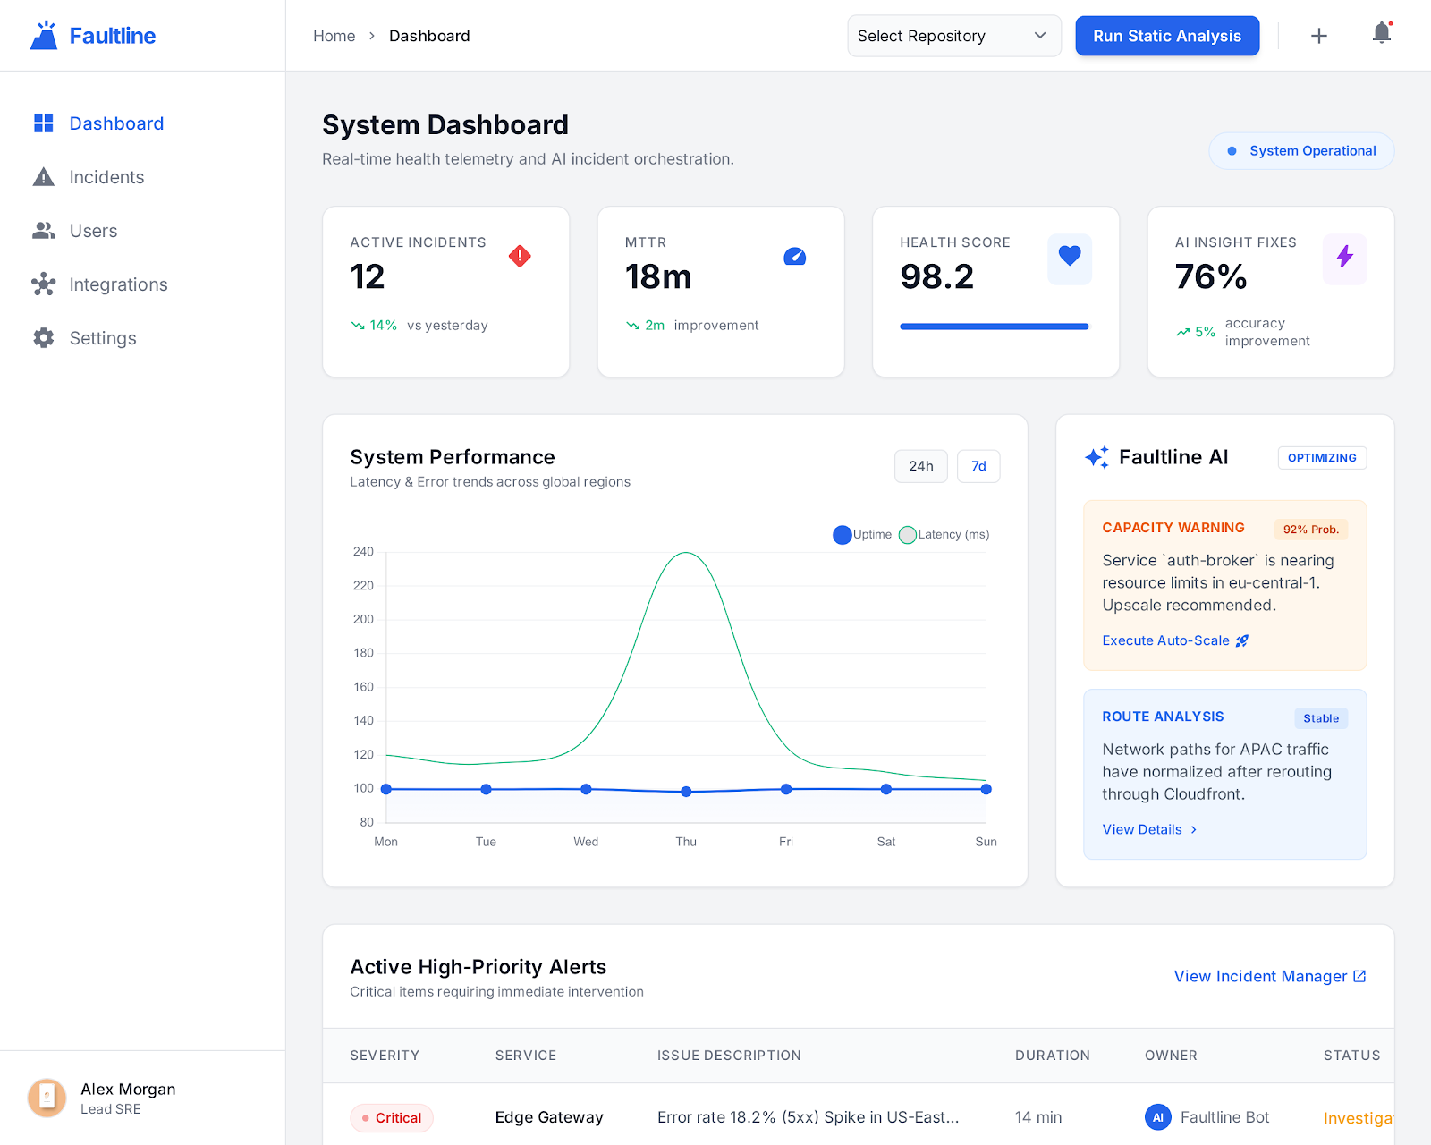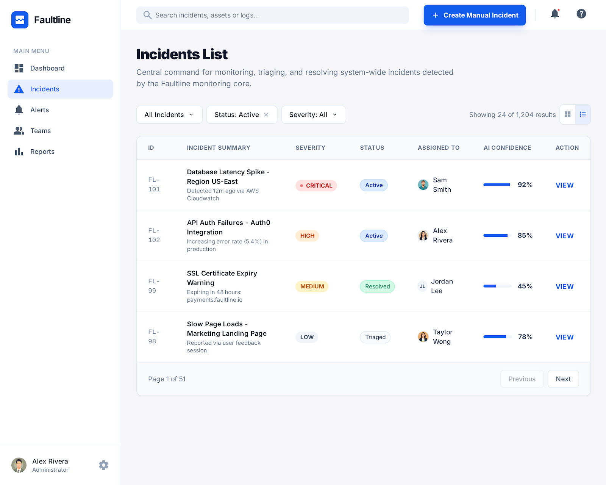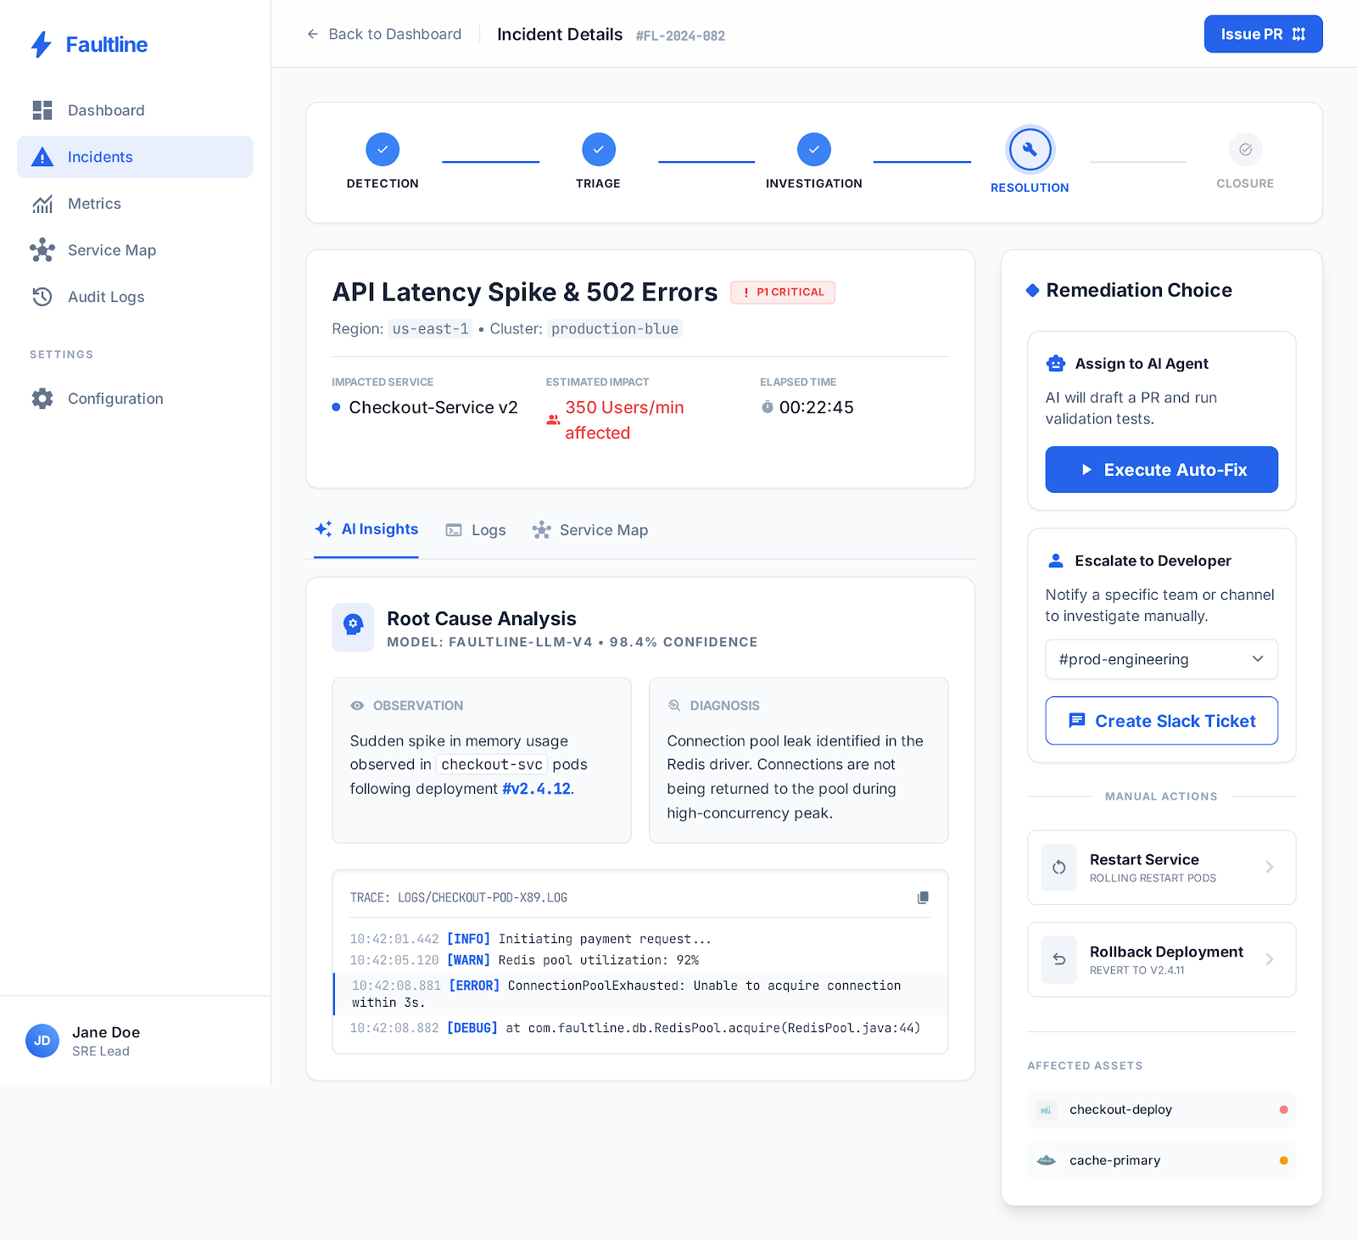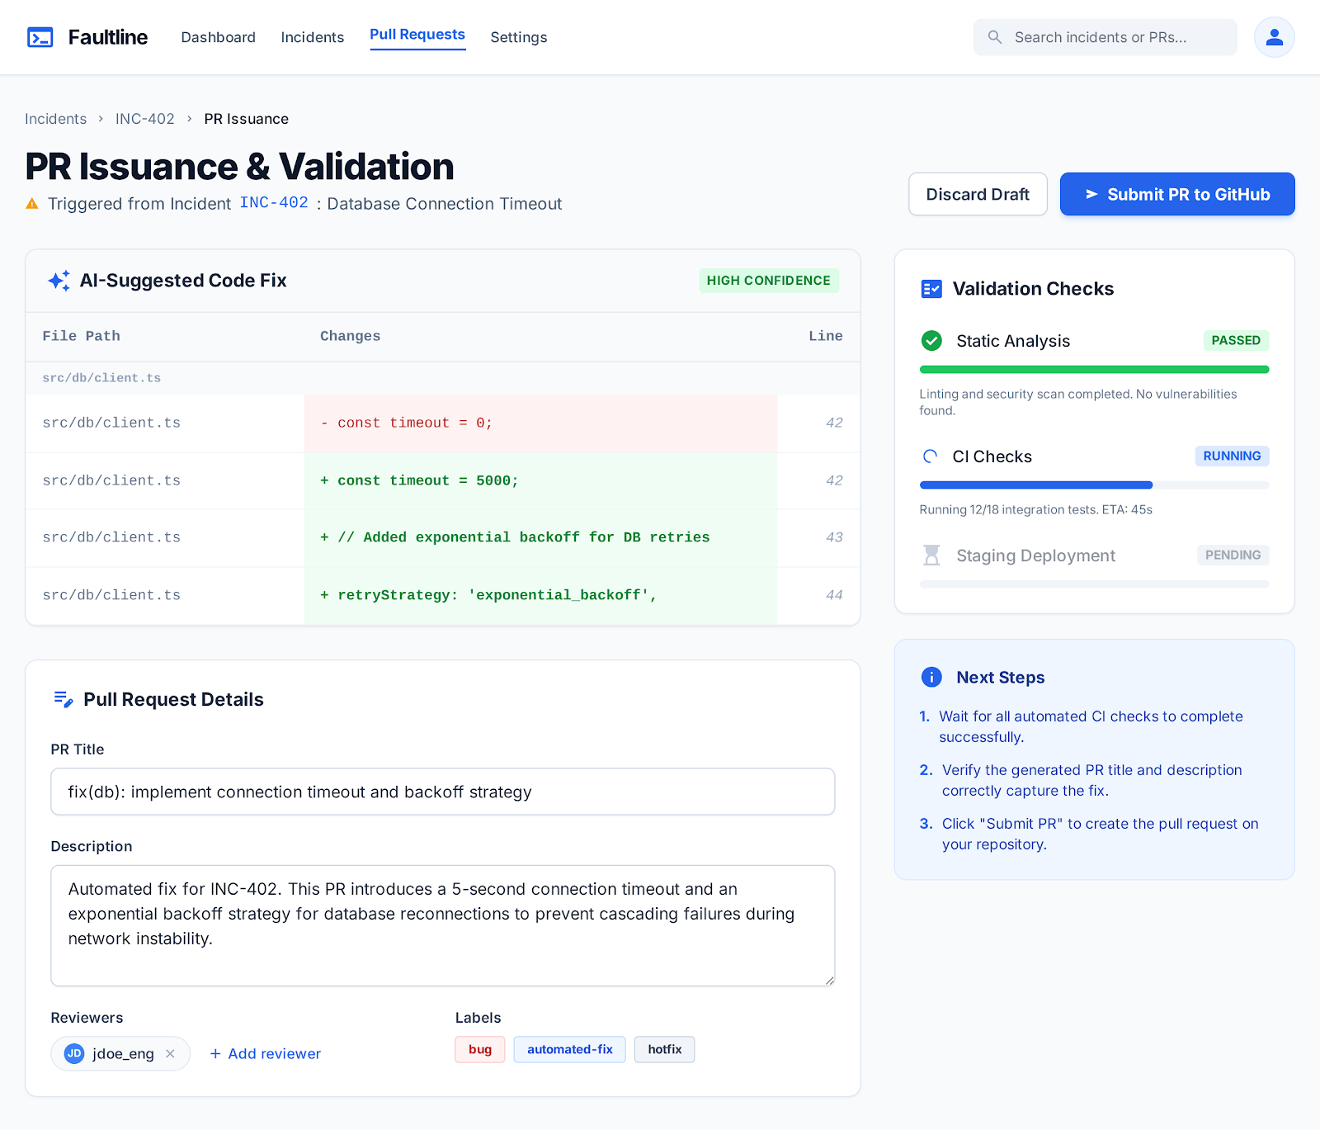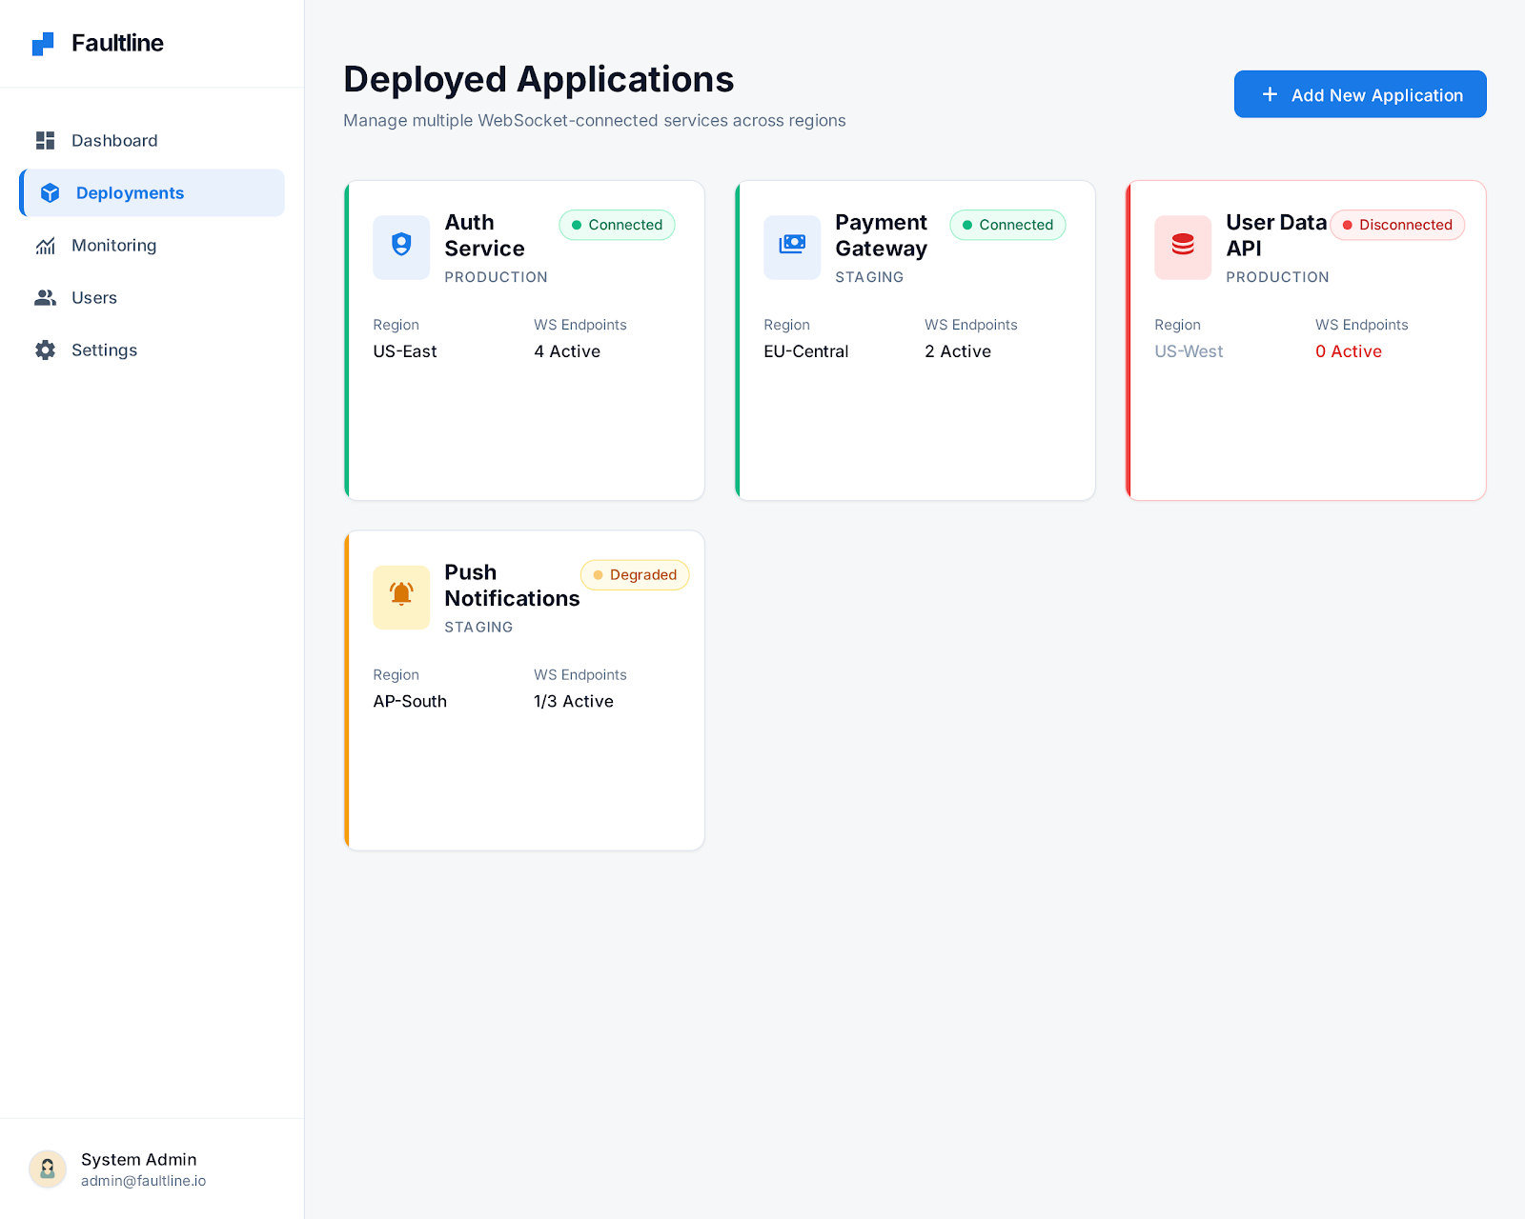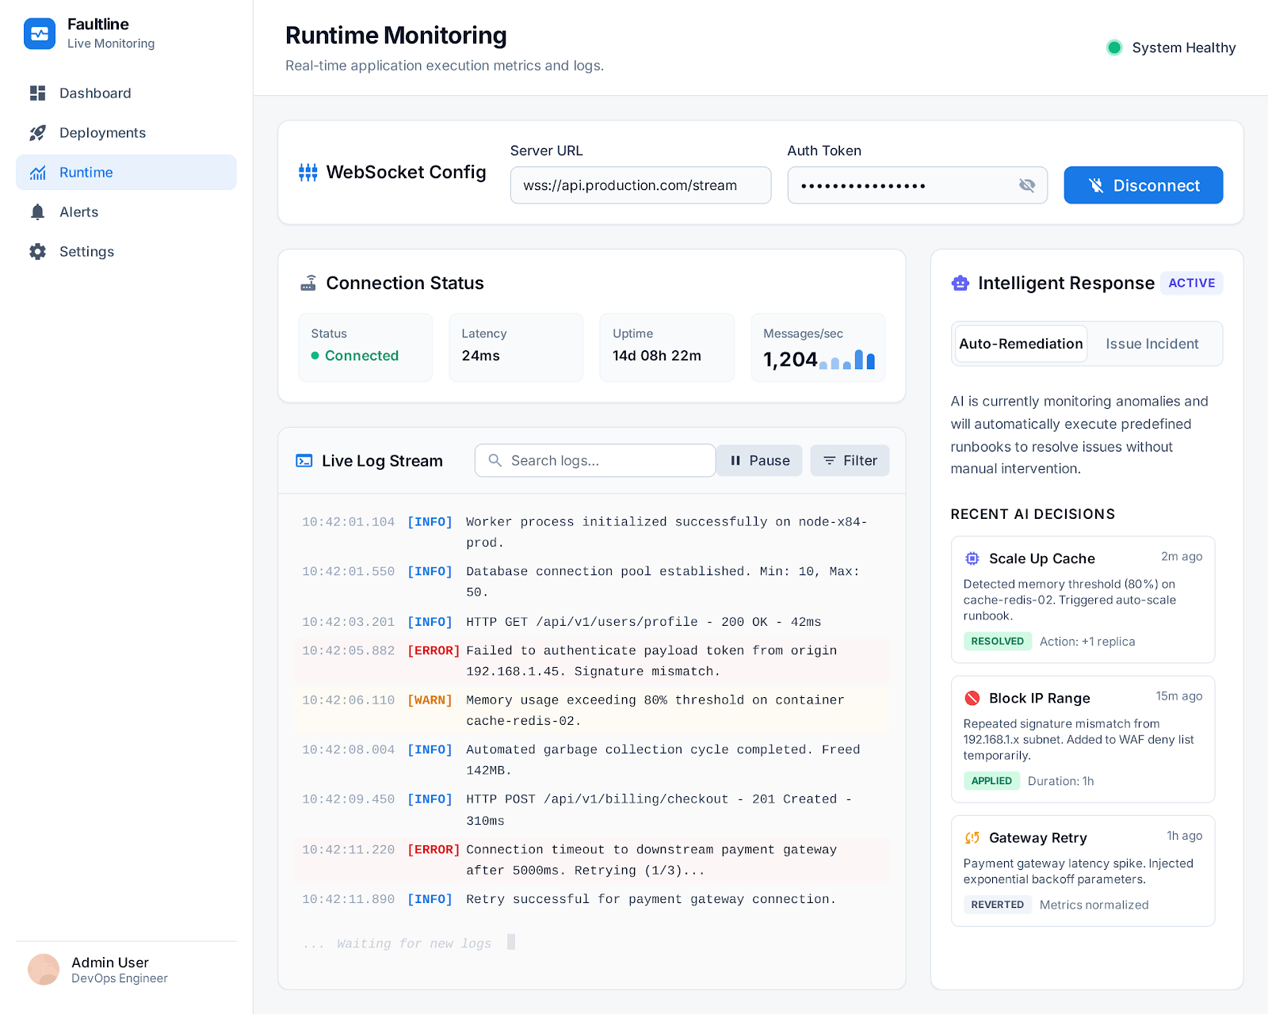

20. References
- Chase, R., et al. (2023). LangChain: Building Applications with LLMs through Composability. GitHub. https://github.com/langchain-ai/langchain
- He, S., Zhu, J., He, P., & Lyu, M. R. (2020). Loghub: A Large Collection of System Log Datasets towards Automated Log Analytics. arXiv preprint arXiv:2008.06448.
- Liu, F. T., Ting, K. M., & Zhou, Z. H. (2008). Isolation Forest. In 2008 Eighth IEEE International Conference on Data Mining (pp. 413-422). IEEE.
- Microsoft Azure. (2024). Azure Monitor REST API Documentation. https://docs.microsoft.com/en-us/azure/azure-monitor/
- Radford, A., Kim, J. W., Xu, T., Brockman, G., McLeavey, C., & Sutskever, I. (2022). Robust Speech Recognition via Large-Scale Weak Supervision (Whisper). OpenAI Technical Report.
- Brown, T., et al. (2020). Language Models are Few-Shot Learners (GPT-3). Advances in Neural Information Processing Systems, 33, 1877-1901.
- OWASP Foundation. (2023). OWASP Top Ten: The Ten Most Critical Web Application Security Risks. https://owasp.org/www-project-top-ten/
- Basiri, A., Behnam, N., de Rooij, R., Hochstein, L., Kosewski, L., Reynolds, J., & Rosenthal, C. (2016). Chaos Engineering. IEEE Software, 33(3), 35-41.

